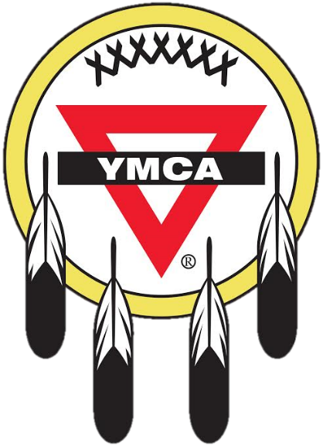

In partnership with the Sioux YMCA, on [Insert Date] the [Insert Organization] acknowledges the [insert Native American Tribe] were the original inhabits and cared for the land that [insert organization] currently occupies.

[Recommended to attach map that shows total area originally inhabited by the Native American tribe(s)]

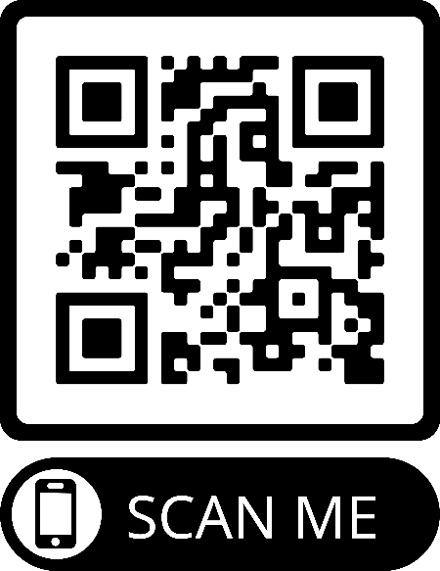

For more resources please go to the Sioux YMCA’s website at www.siouxymca.org or scan this QR code.

